PATHSHALA NEPAL FOUNDATION

PRE-UNI PROGRAM

Baneshwor, Kathmandu



Lab assessment report on

Problems Based on Decision Making

**Submitted By:** **Submitted To**

Name: Raunak Raj Adhikari Department of Computer Science

Class: 11 PATHSHALA NEPAL FOUNDATION

Group: 1

Date: 2023-03-28

1. To find out the greater value between any two integers given.

#include<stdio.h>  
int main()  
{  
int num1, num2;  
printf("Enter two integers: ");  
scanf("%d %d", &num1, &num2);  
if(num1 > num2)  
{  
printf("%d is greater than %d", num1, num2);  
}  
else if(num2 > num1)  
{  
printf("%d is greater than %d", num2, num1);  
}  
else  
{  
printf("Both numbers are equal");  
}  
return 0;  
}

Output:

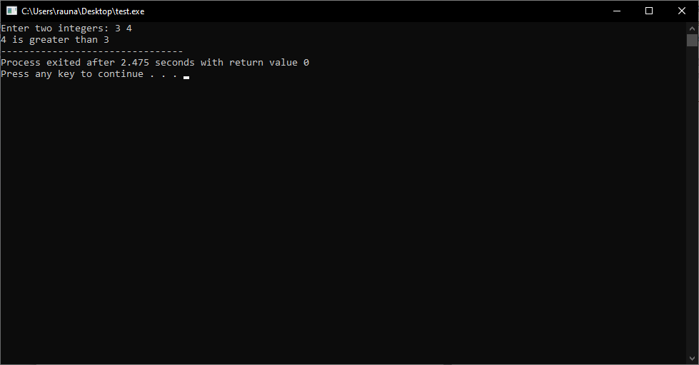

2. To find out the smaller value between any two integers input by a user.

#include <stdio.h>  
  
int main()  
{  
int num1, num2;  
  
printf("Enter two integers: ");  
scanf("%d %d", &num1, &num2);  
  
if (num1 < num2)  
printf("%d is smaller than %d", num1, num2);  
else if (num2 < num1)  
printf("%d is smaller than %d", num2, num1);  
else  
printf("Both numbers are equal");  
  
return 0;  
}

Output:

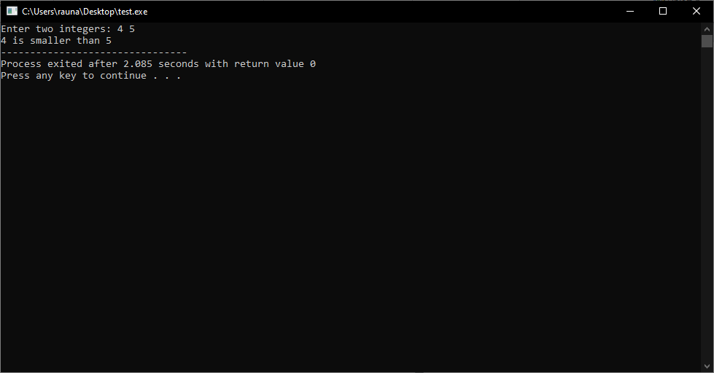

3. To find out the greatest value among any three numbers given.

#include <stdio.h>  
  
int main()  
{  
int num1, num2, num3;  
  
printf("Enter the three numbers: ");  
scanf("%d %d %d", &num1, &num2, &num3);  
  
if (num1 > num2)  
{  
if (num1 > num3)  
printf("%d is the greatest number.", num1);  
else  
printf("%d is the greatest number.", num3);  
}  
else  
{  
if (num2 > num3)  
printf("%d is the greatest number.", num2);  
else  
printf("%d is the greatest number.", num3);  
}  
  
return 0;  
}

Output:

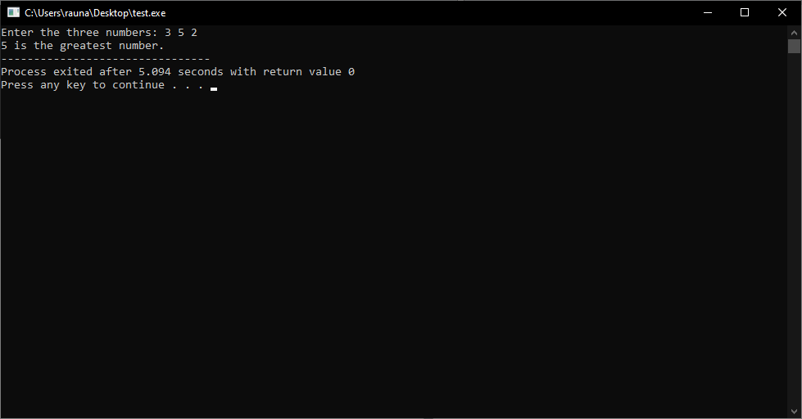

4. To find out the smallest value among any three numbers given.

#include <stdio.h>  
  
int main()  
{  
int num1, num2, num3;  
  
printf("Enter three numbers: ");  
scanf("%d %d %d", &num1, &num2, &num3);  
  
if (num1 < num2)  
{  
if (num1 < num3)  
printf("Smallest number is %d", num1);  
else  
printf("Smallest number is %d", num3);  
}  
else  
{  
if (num2 < num3)  
printf("Smallest number is %d", num2);  
else  
printf("Smallest number is %d", num3);  
}  
  
return 0;  
}

Output:

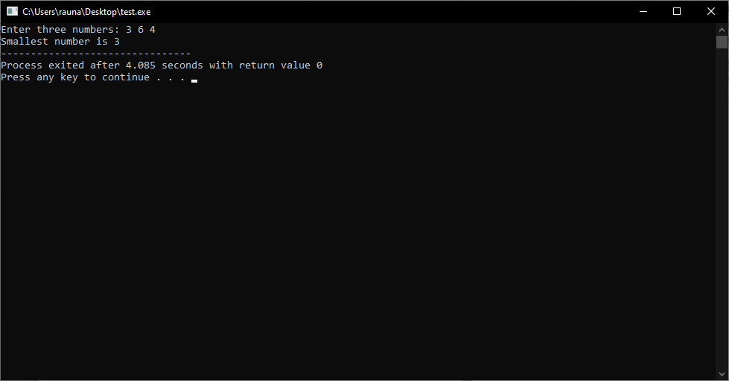

Top of Form

Bottom of Form

5. To find out the median value among any three numbers given.

#include<stdio.h>  
int main()  
{  
int num1, num2, num3;  
float median;  
printf("Enter three numbers: ");  
scanf("%d %d %d", &num1, &num2, &num3);  
if(num1 > num2)  
{  
if(num2 > num3)  
median = num2;  
else if(num1 > num3)  
median = num3;  
else  
median = num1;  
}  
else  
{  
if(num1 > num3)  
median = num1;  
else if(num2 > num3)  
median = num3;  
else  
median = num2;  
}  
printf("Median value is: %f", median);  
  
return 0;  
}

Output:

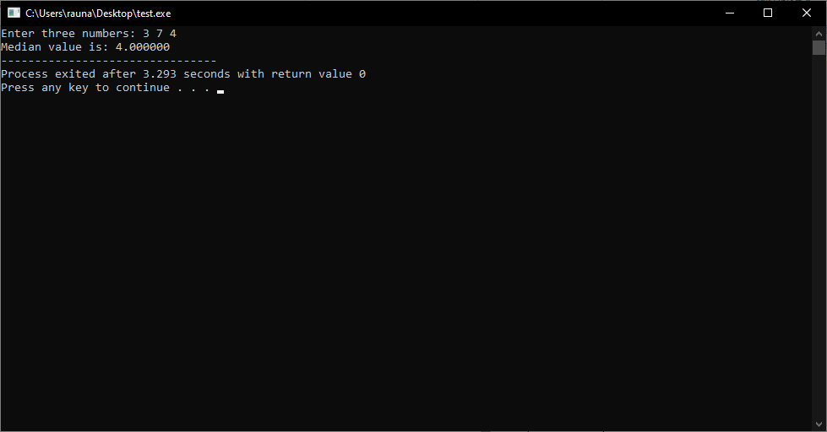

6. To check an integer input by a user is an odd or even.

#include <stdio.h>  
  
int main()  
{  
int num;  
printf("Enter an integer: ");  
scanf("%d", &num);  
  
// If the number is divisible by 2 then it is even  
if (num % 2 == 0)  
printf("%d is even.", num);  
else  
printf("%d is odd.", num);  
  
return 0;  
}

Output:

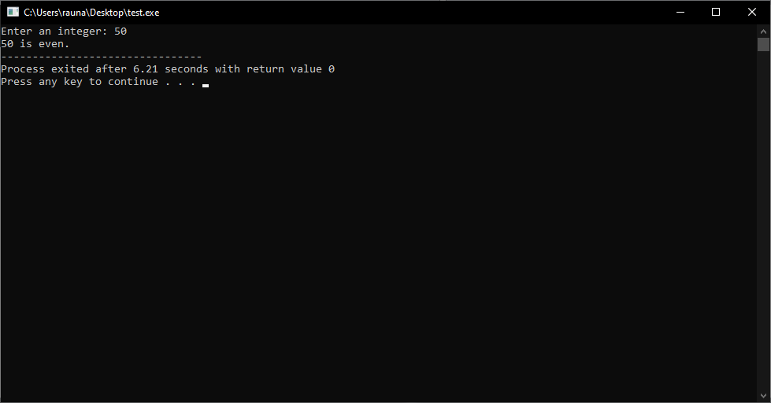

7. To check whether a positive integer input by a user is divisible by 3 or not.

#include <stdio.h>  
  
int main()  
{  
int num;  
printf("Enter a positive integer: ");  
scanf("%d", &num);  
  
if (num % 3 == 0)  
printf("%d is divisible by 3.", num);  
else  
printf("%d is not divisible by 3.", num);  
  
return 0;  
}

Output:

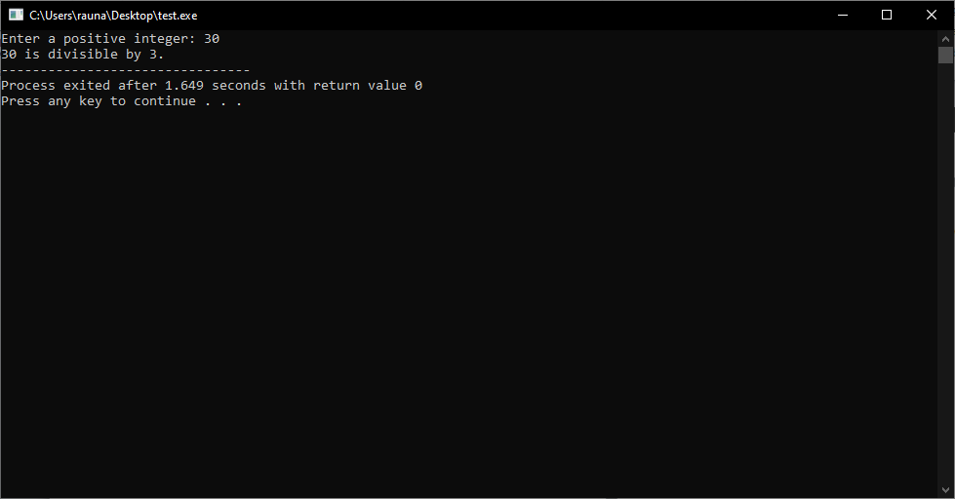

8. To check whether a positive integer input by a user is divisible by 2 or 3 or not.

#include<stdio.h>  
int main()  
{  
int num;  
printf("Enter a positive integer: ");  
scanf("%d",&num);  
if(num%2==0)  
{  
printf("%d is divisible by 2",num);  
}  
else if(num%3==0)  
{  
printf("%d is divisible by 3",num);  
}  
else  
{  
printf("%d is not divisible by 2 or 3",num);  
}  
return 0;  
}

Output:

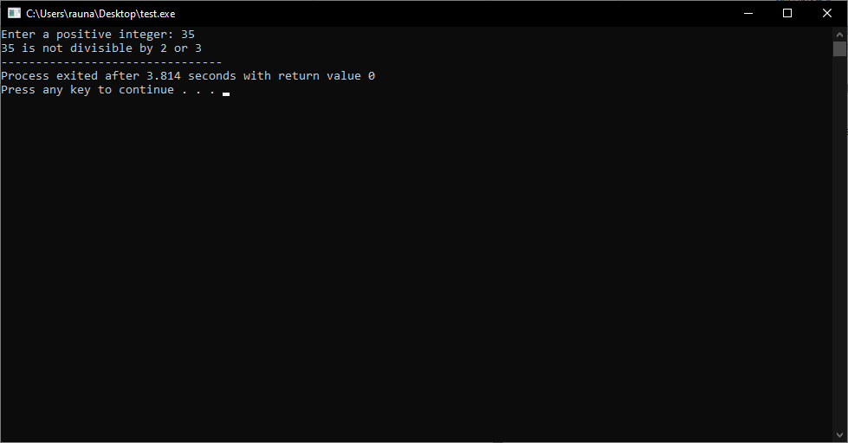

9. To check whether a positive integer input by a user is divisible by 2 and 3 or not.

#include <stdio.h>  
  
int main()  
{  
int num;  
printf("Enter a positive integer: ");  
scanf("%d", &num);  
  
if (num % 2 == 0 && num % 3 == 0)  
printf("%d is divisible by both 2 and 3.", num);  
else  
printf("%d is not divisible by both 2 and 3.", num);  
  
return 0;  
}

Output:

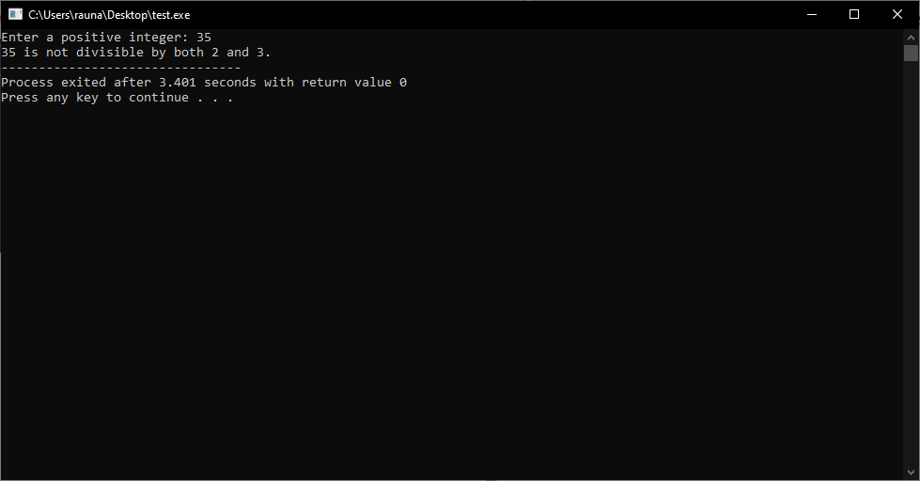

10. To check whether a positive integer input by a user is divisible by 5 but not with 6.

#include <stdio.h>  
  
int main()  
{  
int num;  
printf("Enter a positive integer: ");  
scanf("%d", &num);  
  
if (num % 5 == 0 && num % 6 != 0)  
printf("The number is divisible by 5 but not with 6.\n");  
else  
printf("The number is not divisible by 5 but not with 6.\n");  
  
return 0;  
}

Output:

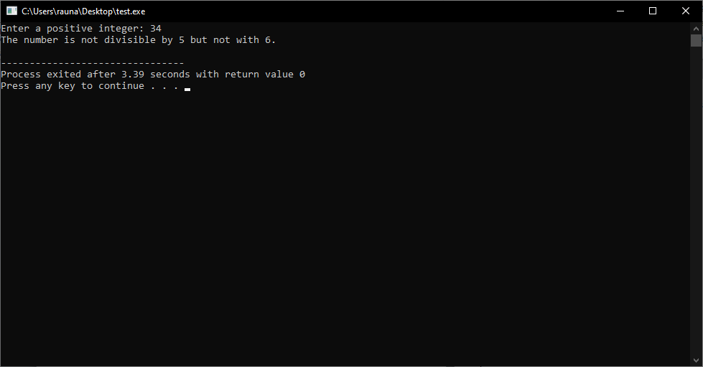

11. To test whether a real number input by a user is an integer or not.

#include <stdio.h>  
int main()  
{  
double num;  
printf("Enter a real number: ");  
scanf("%lf", &num);  
  
// Check if the number is an integer  
if (num == (int)num)  
printf("The number is an integer.\n");  
else  
printf("The number is not an integer.\n");  
  
return 0;  
}

Output:

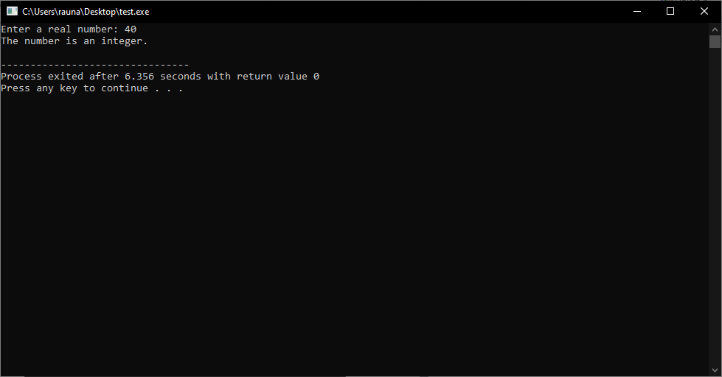

12. To test whether a character input by a user is an alphabet or not.

#include <stdio.h>  
  
int main()  
{  
char ch;  
printf("Enter a character: ");  
scanf("%c", &ch);  
  
if((ch >= 'a' && ch <= 'z') || (ch >= 'A' && ch <= 'Z'))  
printf("%c is an alphabet.", ch);  
else  
printf("%c is not an alphabet.", ch);  
  
return 0;  
}

Output:

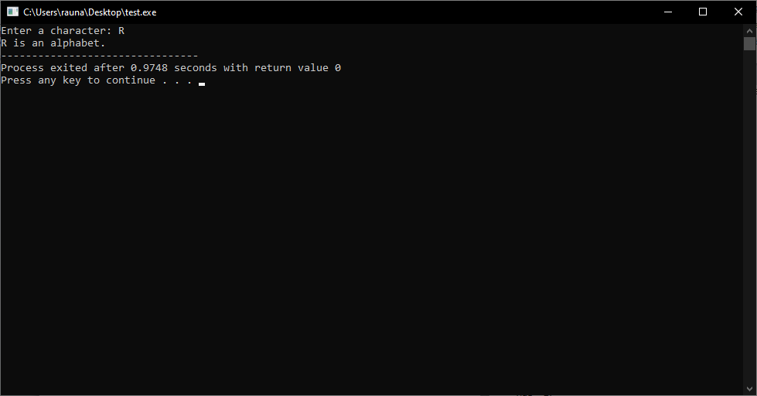

13. To test whether a positive integer input by a user is a perfect square number or not.

#include <stdio.h>  
#include <math.h>   
int main()  
{  
int num;  
int sqrt_num;  
int flag = 0;  
printf("Enter a positive integer: ");  
scanf("%d", &num);  
  
sqrt_num = sqrt(num);  
for (int i = 1; i <= sqrt_num; i++)  
{  
if (i * i == num)  
{  
flag = 1;  
break;  
}  
}  
  
if (flag == 1)  
printf("%d is a perfect square number.\n", num);  
else  
printf("%d is not a perfect square number.\n", num);  
  
return 0;  
}

Output:

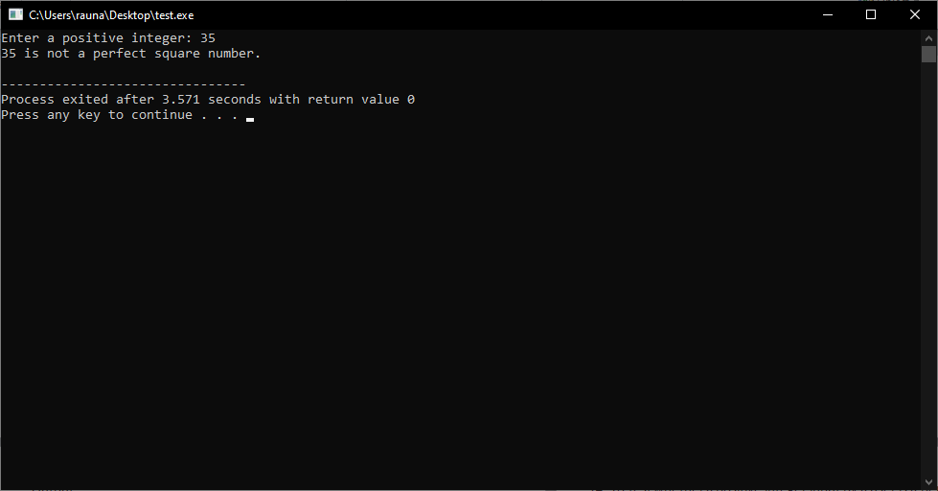

14. To test whether a positive integer input by a user is a perfect cube number or not.

#include <stdio.h>  
#include <math.h>  
int main()  
{  
int num;  
printf("Enter a positive integer: ");  
scanf("%d", &num);  
int cube_root = cbrt(num);  
int cube = cube_root * cube_root * cube_root;  
if (cube == num)  
printf("%d is a perfect cube number.\n", num);  
else  
printf("%d is not a perfect cube number.\n", num);  
return 0;  
}

Output:

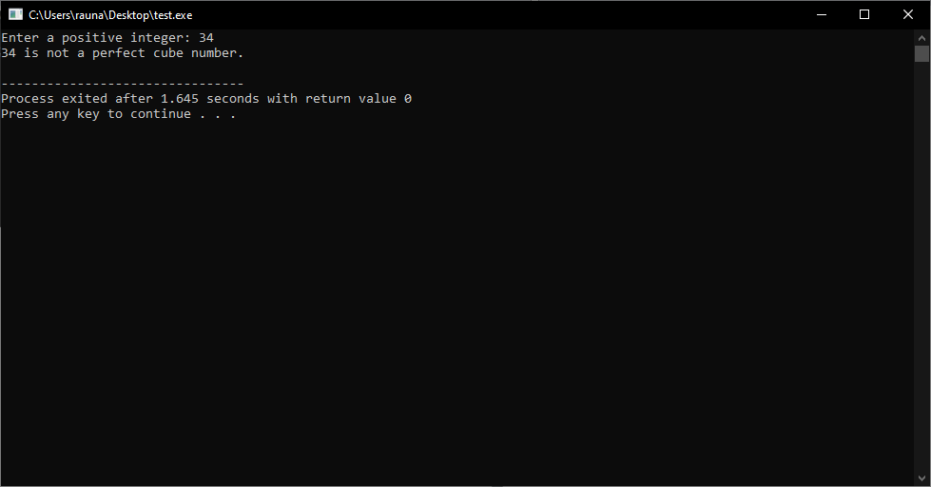

15. To confirm whether a given triangle is a right-angled triangle or not based on its three sides given.

#include<stdio.h>  
#include<math.h>  
int main()  
{  
int side1, side2, side3;  
printf("Enter the three sides of the triangle: \n");  
scanf("%d %d %d", &side1, &side2, &side3);  
if(side1 > side2 && side1 > side3)  
{  
if(pow(side1,2) == (pow(side2,2) + pow(side3,2)))  
printf("The triangle is a right-angled triangle.\n");  
else  
printf("The triangle is not a right-angled triangle.\n");  
}  
else if(side2 > side1 && side2 > side3)  
{  
if(pow(side2,2) == (pow(side1,2) + pow(side3,2)))  
printf("The triangle is a right-angled triangle.\n");  
else  
printf("The triangle is not a right-angled triangle.\n");  
}  
else  
{  
if(pow(side3,2) == (pow(side1,2) + pow(side2,2)))  
printf("The triangle is a right-angled triangle.\n");  
else  
printf("The triangle is not a right-angled triangle.\n");  
}  
return 0;  
}

Output:

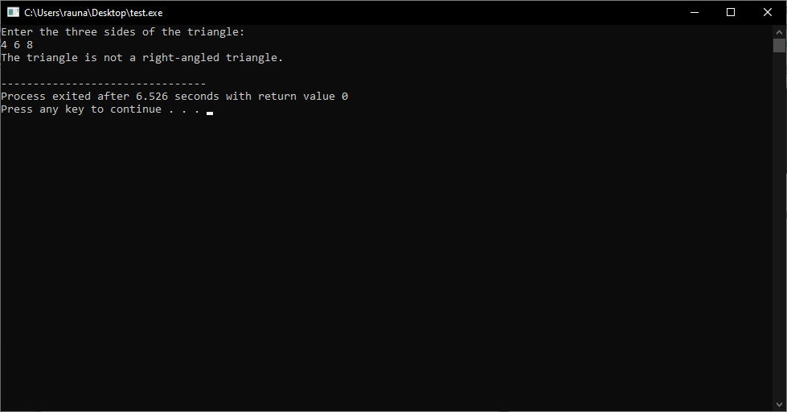

16. To test whether an alphabet input by a user is a vowel or not.

#include <stdio.h>  
  
int main()  
{  
char ch;  
printf("Enter an alphabet: ");  
scanf("%c", &ch);  
  
if(ch=='a' || ch=='A' || ch=='e' || ch=='E' || ch=='i' || ch=='I' || ch=='o' || ch=='O' || ch=='u' || ch=='U')  
printf("%c is a vowel.\n", ch);  
else  
printf("%c is not a vowel.\n", ch);  
return 0;  
}

Output:

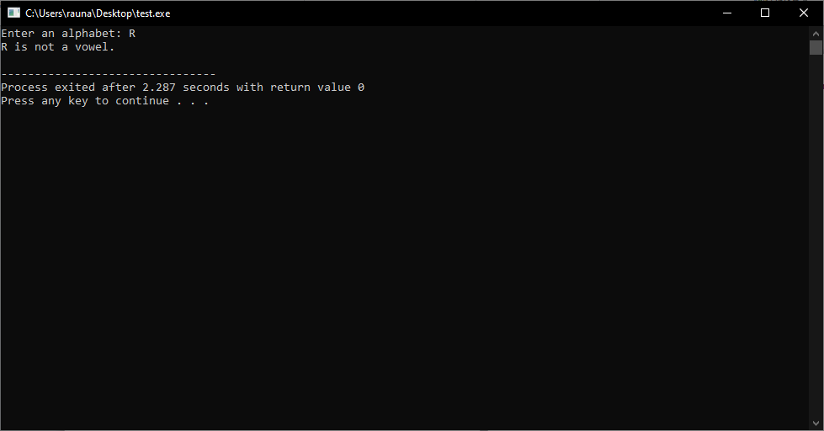

17. To test whether a character input by a user is a special character or not.

#include <stdio.h>  
int main()  
{  
char ch;  
printf("Enter a character: ");  
scanf("%c", &ch);  
  
if((ch >= 'a' && ch <= 'z') || (ch >= 'A' && ch <= 'Z'))  
printf("%c is an alphabet.", ch);  
else if(ch >= '0' && ch <= '9')  
printf("%c is a digit.", ch);  
else  
printf("%c is a special character.", ch);  
return 0;  
}

Output:

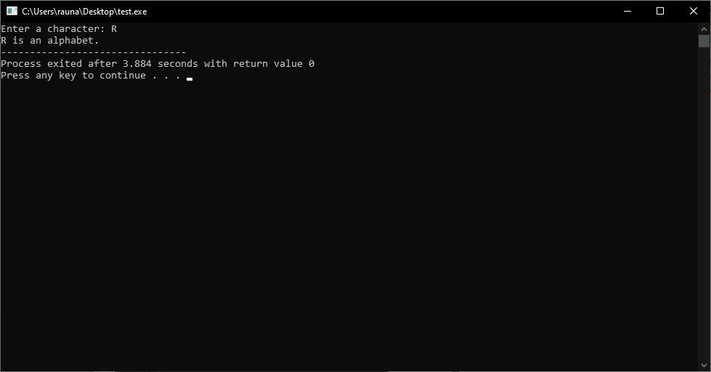

18. To test whether a letter input by a user is a consonant or not.

#include <stdio.h>  
int main()  
{  
char ch;  
printf("Enter a letter: ");  
scanf("%c", &ch);  
  
if (ch == 'a' || ch == 'e' || ch == 'i' || ch == 'o' || ch == 'u' ||  
ch == 'A' || ch == 'E' || ch == 'I' || ch == 'O' || ch == 'U')  
printf("%c is a vowel.\n", ch);  
else  
printf("%c is a consonant.\n", ch);  
return 0;  
}

Output:

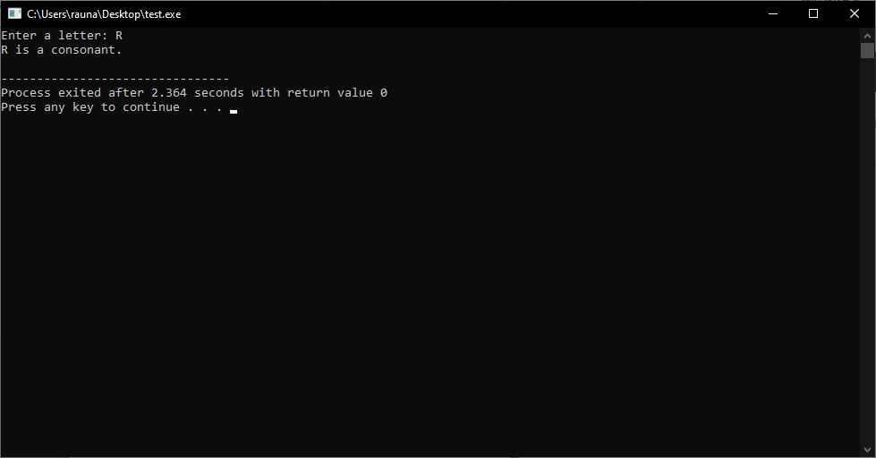

19. To test whether a positive integer input by a user is a PRIME or not.

#include <stdio.h>  
  
int main()  
{  
int num, i, flag = 0;  
  
printf("Enter a positive integer: ");  
scanf("%d", &num);  
  
for(i = 2; i <= num/2; ++i)  
{  
// condition for nonprime number  
if(num%i == 0)  
{  
flag = 1;  
break;  
}  
}  
  
if (flag == 0)  
printf("%d is a prime number.", num);  
else  
printf("%d is not a prime number.", num);  
  
return 0;  
}

Output:

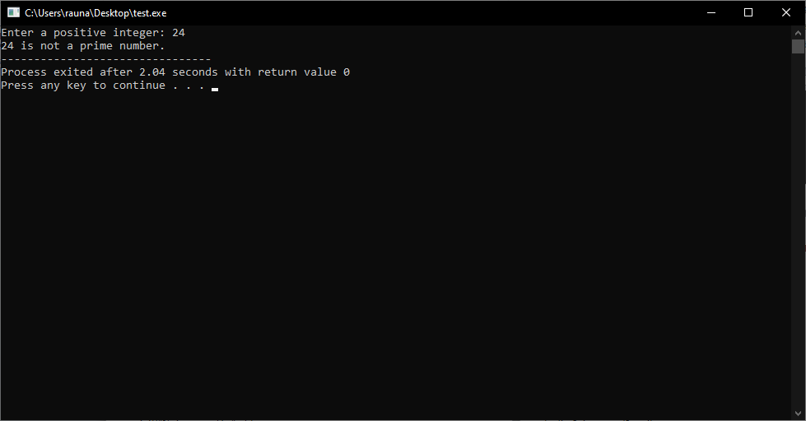

20. The sales tax ( in percentage of the factory price) on cars is given below: Factory price (in Rupees) => Sales tax (in percentage) [Below 800000 => 5, 800000 and below 1500000 => 7, 1500000 and above => 10] The transport handling charges are Rs. 10000. Find the total cost of the car, if the factory price is given.

#include<stdio.h>  
int main()  
{  
int factory_price, sales_tax, total_cost;  
printf("Enter the factory price of the car: ");  
scanf("%d", &factory_price);  
if(factory_price < 800000)  
{  
sales_tax = 5;  
}  
else if(factory_price >= 800000 && factory_price < 1500000)  
{  
sales_tax = 7;  
}  
else  
{  
sales_tax = 10;  
}  
total_cost = factory_price + (factory_price * sales_tax/100) + 10000;  
printf("The total cost of the car is: %d", total_cost);  
return 0;  
}

Output:

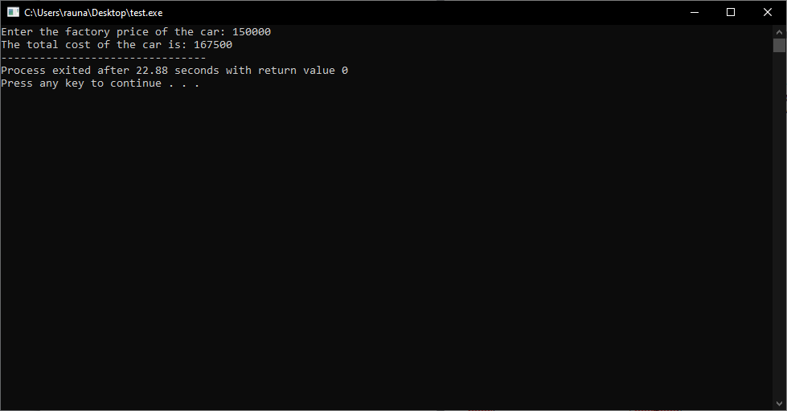

21. A worker is paid Rs. 10 per hour for his work in a biscuit factory. He is paid Rs. 15 per hour for the extra hours in excess of the usual 40 hours per week. The weekly maximum working hour is 72. Write a program to find the pay for the worker whose number of working hours in a week is given.

#include<stdio.h>  
  
int main()  
{  
int hours, pay;  
printf("Enter the number of hours worked in a week: ");  
scanf("%d", &hours);  
  
if(hours <= 40)  
{  
pay = hours * 10;  
}  
else if(hours > 40 && hours <= 72)  
{  
pay = (40 * 10) + ((hours - 40) * 15);  
}  
else  
{  
printf("Invalid number of hours worked!\n");  
return 0;  
}  
  
printf("The worker's pay is Rs. %d\n", pay);  
  
return 0;  
}

Output:

